Prompt for badge generator:
Create a fully standalone web application named Top Performer Badge Generator.

Requirements:
* Deliver as a single downloadable HTML file.
* Must work 100% offline.
* Do not use any external links, libraries, or internet resources.
* Everything must be built inside the file.
* Automatically generate and provide the HTML file for download, not just show code.

Layout:
* Full-screen responsive design that works properly on: Desktop screens Laptops Tablets Mobile devices
* On desktop: Display a two-panel layout (left: input form, right: badge preview)
* On mobile: Stack panels vertically for better usability
* Use an attractive gradient background
* Centered header at the top:
Title: Top Performer Badge Generator
Subtitle: Encouragement and motivation is a key to spark learning
Input Panel (Left):
Fields: Student Name
University ID Subject
Score (%)
Buttons: Generate Card
Download Badge Badge

Panel (Right):
On Generate Card: Display a styled congratulatory badge
Show: Student Name
University ID
Subject Score
Bold “Top Performer” label
Random motivational message
Trigger confetti animation Confetti disappears automatically after a few seconds

On Download Badge:
Download the badge as a high-quality PNG image Must work completely offline Design:
* Modern and professional UI
* Smooth animations
* Clean layout
* Good spacing and alignment
* Desktop and mobile optimized Output: Generate and return the downloadable HTML file.
Your fully standalone offline web application is ready. 🌟
Download the Top Performer Badge Generator

Installation Guide for Gemini open source cli agent
- https://github.com/https-deeplearning-ai/sc-gemini-cli-files

This guide explains how to install and configure the official Google Gemini CLI (@google/gemini-cli).

Prerequisites
Before installing, ensure your system meets the following requirements:
- Node.js: Version 20.0.0 or higher is recommended (Minimum v18).
  - Check version: node -v
  - Download: nodejs.org
- Google Account: Required for authentication (Free tier available).

Installation Methods

Option 1: NPM (Recommended)
This is the standard method for most users (Windows, macOS, Linux). It installs the CLI globally on your system.
- Open your terminal or command prompt.
- Run the install command:npm install -g @google/gemini-cli
(Note: On Linux or macOS, you might need to use sudo if you encounter permission errors: sudo npm install -g @google/gemini-cli)

Option 2: Homebrew (macOS)
If you use Homebrew on macOS, you can install it directly.
- Run the brew install command:brew install gemini-cli

Option 3: NPX (No Install / One-time Use)
If you want to run the CLI without permanently installing it, use npx. This always fetches the latest version.
- Run the command:npx @google/gemini-cli

Authentication
Once installed, you need to authenticate. The CLI supports a browser-based login flow which is the easiest to set up.
- Run the CLI for the first time:gemini
- The CLI will prompt you to select an authentication method.
- Select "Login with Google" (using arrow keys and Enter).
- A browser window will open. Sign in with your Google Account.
- Once authorized, close the browser window. The terminal will confirm you are logged in.

Alternative: API Key
If you prefer using an API key (e.g., for automated scripts or enterprise environments), you can set it as an environment variable.
- Get a key from Google AI Studio.
- Set the variable in your terminal:
  - Mac/Linux: export GEMINI_API_KEY="YOUR_KEY_HERE"
  - Windows (PowerShell): $env:GEMINI_API_KEY="YOUR_KEY_HERE"

Verification
To verify the installation was successful, check the version or run a simple prompt.
gemini –version

If you get command not found
- Confirm install: npm list -g @google/gemini-cli
- Confirm path: echo $PATH should include something like .../.npm-global/bin
- Confirm binary: ls -la ~/.npm-global/bin/gemini

Cause: With prefix=~/.npm-global in ~/.npmrc, the gemini shim lives in ~/.npm-global/bin, which was missing from PATH.
Fix: Add that directory to PATH in ~/.zshrc so new shells (and source ~/.zshrc) pick up global npm binaries.

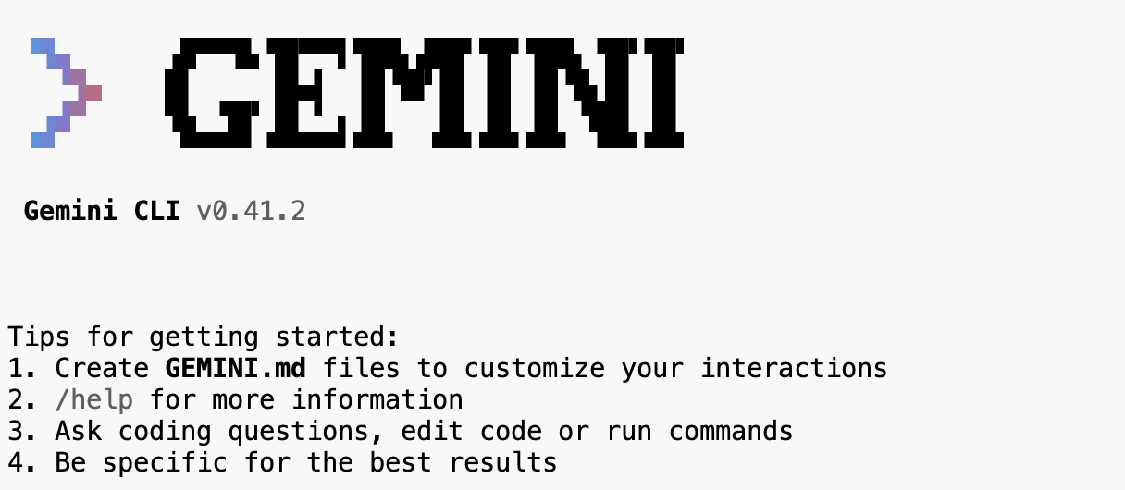
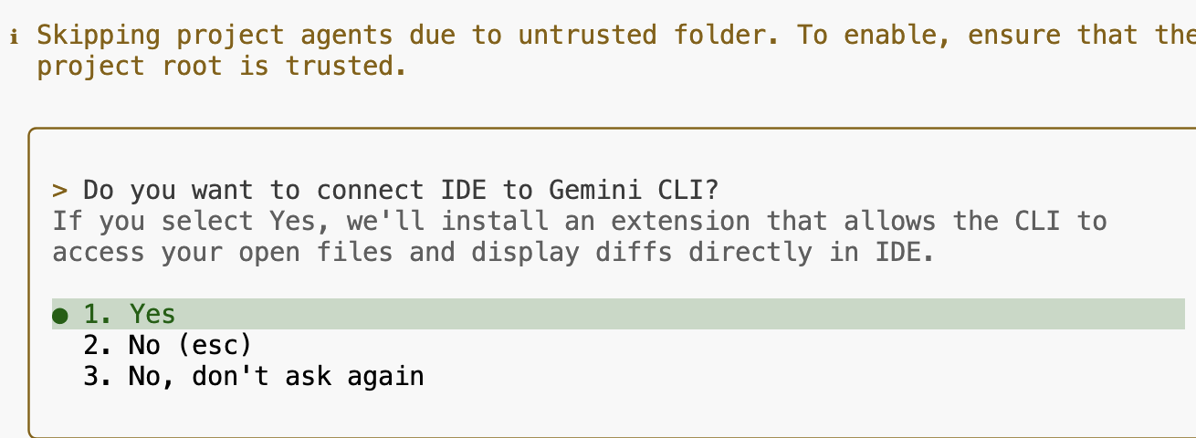
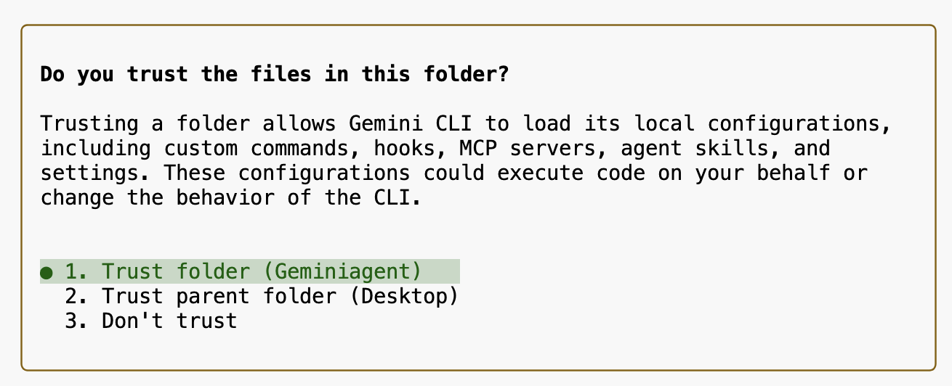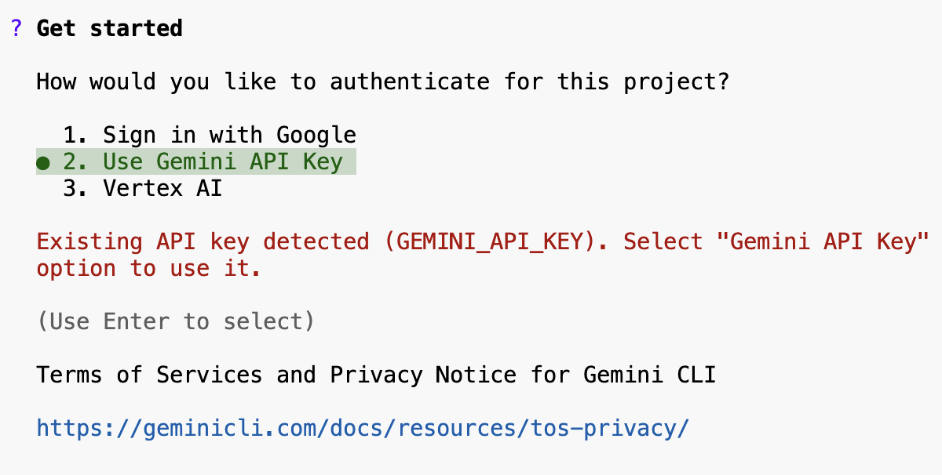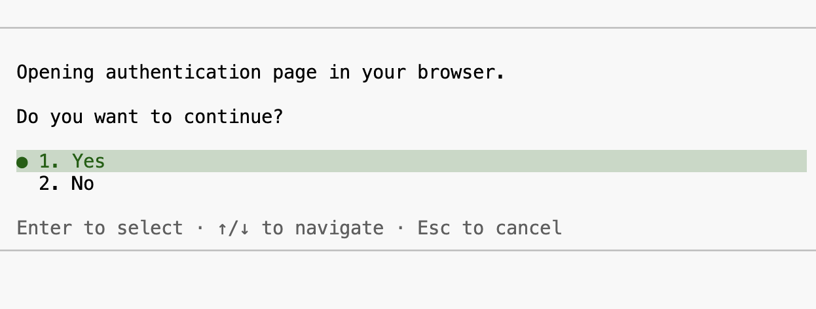
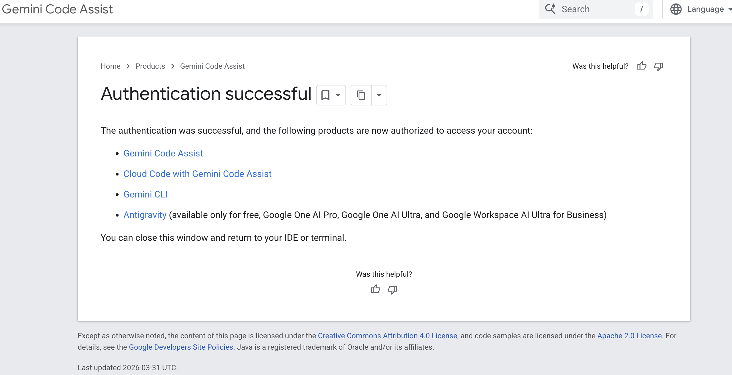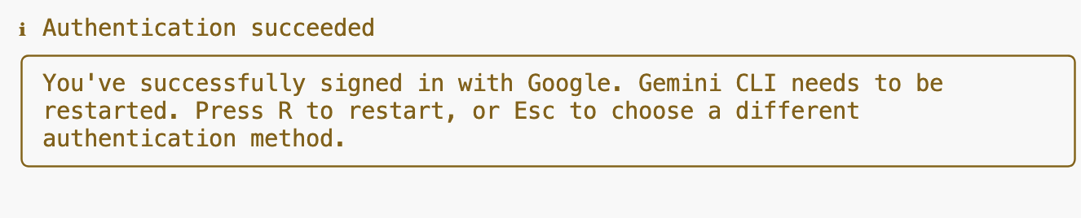

Another coding agent:
https://github.com/Rashpinder1985/PersonalCodingAgent

